**2.2.10 TLP Prefix Rules**

The following rules apply to any TLP that contains a TLP Prefix:

• For any TLP, a value of 100b in the Fmt[2:0] field in byte 0 of the TLP indicates the presence of a TLP Prefix and the Type[4] bit indicates the type of TLP Prefix.

◦ A value of 0b in the Type[4] bit indicates the presence of a Local TLP Prefix

◦ A value of 1b in the Type[4] bit indicates the presence of an End-End TLP Prefix

• The format for bytes 1 through 3 of a TLP Prefix are defined by its TLP Prefix type.

• A TLP that contains a TLP Prefix must have an underlying TLP Header. A received TLP that violates this rule is handled as a Malformed TLP. This is a reported error associated with the Receiving Port (see Section 6.2 ).

• It is permitted for a TLP to contain more than one TLP Prefix of any type

◦ When a combination of Local and End-End TLP Prefixes are present in TLP, it is required that all the Local TLP Prefixes precede any End-End TLP Prefixes. A received TLP that violates this rule is handled as a Malformed TLP. This is a reported error associated with the Receiving Port (see Section 6.2 ).

• The size of each TLP Prefix is 1 DW. A TLP Prefix may be repeated to provide space for additional data.• If the value in the Fmt and Type field indicates the presence of a Local TLP Prefix, handle according to the Local TLP Prefix handling (see Section 2.2.10.1 ).

• If the value in the Fmt and Type field indicates the presence of an End-End TLP Prefix, handle according to the End-End TLP Prefix handling (see Section 2.2.10.2 ).

以下规则适用于任何包含 TLP 前缀的 TLP：

• 对于任何 TLP，TLP 字节 0 中的 Fmt[2:0] 字段中的值为 100b 表示存在 TLP 前缀，而 Type[4] 位表示 TLP 前缀的类型。

◦ Type[4] 位中的值为 0b 表示存在本地 TLP 前缀。

◦ Type[4] 位中的值为 1b 表示存在端到端 TLP 前缀。

• TLP 前缀的字节 1 到 3 的格式由其 TLP 前缀类型定义。

•包含 TLP 前缀的 TLP 必须具有底层 TLP 标头。

违反此规则的接收 TLP 将被处理为格式错误的 TLP。这是与接收端口相关的报告错误（请参阅第 6.2 节）。

• 允许 TLP 包含多个任何类型的 TLP 前缀

◦ 当 TLP 中存在本地和端到端 TLP 前缀的组合时，要求所有本地 TLP 前缀都位于任何端到端 TLP 前缀之前。违反此规则的接收 TLP 将被视为格式错误的 TLP。这是与接收端口相关的报告错误（请参阅第 6.2 节）。

• 每个 TLP 前缀的大小为 1 DW。可以重复 TLP 前缀以提供用于其他数据的空间。

• 如果 Fmt 和 Type 字段中的值指示存在本地 TLP 前缀，则根据本地 TLP 前缀处理进行处理（参见第 2.2.10.1 节）。

• 如果 Fmt 和 Type 字段中的值指示存在端到端 TLP 前缀，则根据端到端 TLP 前缀处理进行处理（参见第 2.2.10.2 节）。

**2.2.10.1 Local TLP Prefix Processing**

The following rules apply to Local TLP Prefixes:

• Local TLP Prefix types are determined using the L[3:0] sub-field of the Type field

◦ Type[4] must be 0b

◦ Local TLP Prefix L[3:0] values are defined in Table 2-36

以下规则适用于本地 TLP 前缀：

• 本地 TLP 前缀类型通过 Type 字段的 L[3:0] 子字段确定

◦ Type[4] 必须为 0b

◦本地 TLP 前缀 L[3:0] 值在表 2-36 中定义

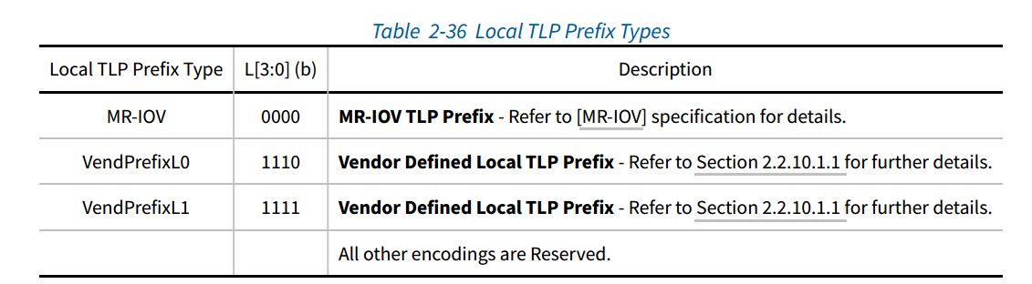

• The size, routing, and flow control rules are specific to each Local TLP Prefix type.

• It is an error to receive a TLP with a Local TLP Prefix type not supported by the Receiver. If the Extended Fmt Field Supported bit is Set, TLPs in violation of this rule are handled as a Malformed TLP unless explicitly stated differently in another specification. This is a reported error associated with the Receiving Port (see Section 6.2). If the Extended Fmt Field Supported bit is Clear, behavior is device specific.

• No Local TLP Prefixes are protected by ECRC even if the underlying TLP is protected by ECRC.

• 大小、路由和流量控制规则特定于每个本地 TLP 前缀类型。

• 接收具有接收器不支持的本地 TLP 前缀类型的 TLP 是错误的。如果设置了扩展格式字段支持位，则违反此规则的 TLP 将被视为格式错误的 TLP，除非其他规范中明确规定不同。这是与接收端口相关的报告错误（请参阅第 6.2 节）。如果清除了扩展格式字段支持位，则行为特定于设备。

• 即使底层 TLP 受 ECRC 保护，也没有本地 TLP 前缀受 ECRC 保护。

**2.2.10.1.1 Vendor Defined Local TLP Prefix**

As described in Table 2-36 , Types VendPrefixL0 and VendPrefixL1 are Reserved for use as Vendor Defined Local TLP Prefixes. To maximize interoperability and flexibility the following rules are applied to such prefixes:

• Components must not send TLPs containing Vendor Defined Local TLP Prefixes unless this has been explicitly enabled (using vendor-specific mechanisms).

• Components that support any usage of Vendor Defined Local TLP Prefixes must support the 3-bit definition of the Fmt field and have the Extended Fmt Field Supported bit Set (see Section 7.5.3.15 ).

• It is recommended that components be configurable (using vendor-specific mechanisms) so that all vendor defined prefixes can be sent using either of the two Vendor Defined Local TLP Prefix encodings. Such configuration need not be symmetric (for example each end of a Link could transmit the same Prefix using a different encoding)

如表 2-36 所述，类型 VendPrefixL0 和 VendPrefixL1 保留用作供应商定义的本地 TLP 前缀。为了最大限度地提高互操作性和灵活性，对此类前缀应用以下规则：• 组件不得发送包含供应商定义的本地 TLP 前缀的 TLP，除非已明确启用此功能（使用供应商特定的机制）。

• 支持使用任何供应商定义的本地 TLP 前缀的组件必须支持 Fmt 字段的 3 位定义，并设置扩展 Fmt 字段支持位（参见第 7.5.3.15 节）。

• 建议组件可配置（使用供应商特定的机制），以便可以使用两种供应商定义的本地 TLP 前缀编码中的任一种发送所有供应商定义的前缀。此类配置不必是对称的（例如，链路的每一端都可以使用不同的编码传输相同的前缀）。

**2.2.10.2 End-End TLP Prefix Processing**

The following rules apply to End-End TLP Prefixes

• End-End TLP Prefix types are determined using the E[3:0] sub-field of the Type field

◦ Type[4] must be 1b

◦ End-End TLP Prefix E[3:0] values are defined in Table 2-37

以下规则适用于端到端 TLP 前缀：

• 使用 Type 字段的 E[3:0] 子字段确定端到端 TLP 前缀类型

◦ Type[4] 必须为 1b

◦ 端到端 TLP 前缀 E[3:0] 值在表 2-37 中定义

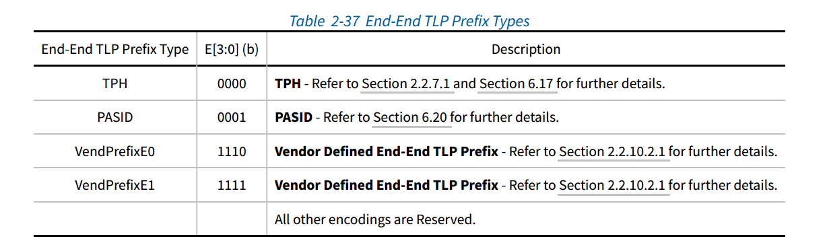

• The maximum number of End-End TLP Prefixes permitted in a TLP is 4:

◦ A Receiver supporting TLP Prefixes must check this rule. If a Receiver determines that a TLP violates this rule, the TLP is a Malformed TLP. This is a reported error associated with the Receiving Port (see Section 6.2 ).

• The presence of an End-End TLP Prefix does not alter the routing of a TLP. TLPs are routed based on the routing rules covered in Section 2.2.4 .

• Functions indicate how many End-End TLP Prefixes they support by the Max End-End TLP Prefixes field in the Device Capabilities 2 register (see Section 7.5.3.15 ).

◦ For Root Ports, the Max End-End TLP Prefixes field is permitted to return a value indicating support

for fewer End-End TLP Prefixes than what the Root Port hardware actually implements; however, the error handling semantics must still be based on the value contained in the field. TLPs received that contain more End-End TLP Prefixes than are supported by the Root Port must be handled as follows.

It is recommended that Requests be handled as Unsupported Requests, but otherwise they must be

handled as Malformed TLPs. It is recommended that Completions be handled as Unexpected Completions, but otherwise they must be handled as Malformed TLPs. For TLPs received by the Ingress Port, this is a reported error associated with the Ingress Port. For TLPs received internally to be transmitted out the Egress Port, this is a reported error associated with the Egress Port. See Section 6.2 .

◦ For all other Function types, TLPs received that contain more End-End TLP Prefixes than are supported by a Function must be handled as Malformed TLPs. This is a reported error associated with the Receiving Port (see Section 6.2 ).

Advanced Error Reporting (AER) logging (if supported) occurs as specified in Section 6.2.4.4 .

• Switches must support forwarding of TLPs with up to 4 End-End TLP Prefixes if the End-End TLP Prefix Supported bit is Set.

• Different Root Ports with the End-End TLP Prefix Supported bit Set are permitted to report different values for Max End-End TLP Prefixes.

• All End-End TLP Prefixes are protected by ECRC if the underlying TLP is protected by ECRC.

• It is an error to receive a TLP with an End-End TLP Prefix by a Receiver that does not support End-End TLP

Prefixes. A TLP in violation of this rule is handled as a Malformed TLP. This is a reported error associated with the Receiving Port (see Section 6.2 ).

• Software should ensure that TLPs containing End-End TLP Prefixes are not sent to components that do not support them. Components where the Extended Fmt Field Supported bit is Clear may misinterpret TLPs containing TLP Prefixes.

• If one Function of an Upstream Port has the End-End TLP Prefix Supported bit Set, all Functions of that Upstream Port must handle the receipt of a Request addressed to them that contains an unsupported End-End

TLP Prefix type as an Unsupported Request. This is a reported error associated with the Receiving Port (see Section 6.2 ).

• If one Function of an Upstream Port has the End-End TLP Prefix Supported bit Set, all Functions of that Upstream Port must handle the receipt of a Completion addressed to them that contains an unsupported End-End TLP Prefix type as an Unexpected Completion. This is a reported error associated with the Receiving Port (see Section 6.2 ).

• For Routing Elements, the End-End TLP Prefix Blocking bit in each Egress Port determines whether TLPs containing End-End TLP Prefixes can be transmitted via that Egress Port (see Section 7.5.3.16 ). If forwarding is blocked the entire TLP is dropped and a TLP Prefix Blocked Error is reported. If the blocked TLP is a Non-Posted Request, the Egress Port returns a Completion with Unsupported Request Completion Status. The TLP Prefix Blocked Error is a reported error associated with the Egress Port (see Section 6.2 ).

• For routing elements where Multicast is enabled (see Section 6.14 ). End-End TLP Prefixes are replicated in all Multicast copies of a TLP. TLP Prefix Egress Blocking of Multicast packets is performed independently at each Egress Port.

• TLP 中允许的最大端到端 TLP 前缀数为 4：

◦ 支持 TLP 前缀的接收器必须检查此规则。如果接收器确定 TLP 违反了此规则，则该 TLP 为格式错误的 TLP。这是与接收端口相关的报告错误（请参阅第 6.2 节）。

• 端到端 TLP 前缀的存在不会改变 TLP 的路由。TLP 根据第 2.2.4 节中介绍的路由规则进行路由。

• 功能通过设备功能 2 寄存器中的最大端到端 TLP 前缀字段指示它们支持多少个端到端 TLP 前缀（请参阅第 7.5.3.15 节）。

◦ 对于根端口，允许最大端到端 TLP 前缀字段返回一个值，该值表示支持的端到端 TLP 前缀少于根端口硬件实际实现的前缀数；但是，错误处理语义仍然必须基于字段中包含的值。如果接收到的 TLP 包含的端到端 TLP 前缀多于根端口支持的前缀，则必须按如下方式处理。

建议将请求作为不支持的请求处理，否则必须将其作为格式错误的 TLP 处理。建议将完成作为意外完成处理，否则必须将其作为格式错误的 TLP 处理。对于入口端口接收到的 TLP，这是与入口端口相关的报告错误。对于内部接收的要从出口端口传输出去的 TLP，这是与出口端口相关的报告错误。请参阅第 6.2 节。

◦ 对于所有其他功能类型，如果接收到的 TLP 包含的端到端 TLP 前缀多于功能支持的前缀，则必须将其作为格式错误的 TLP 处理。这是与接收端口相关的报告错误（请参阅第 6.2 节）。

高级错误报告 (AER) 日志记录（如果支持）按第 6.2.4.4 节中所述进行。

• 如果设置了“端到端 TLP 前缀支持”位，交换机必须支持转发最多 4 个端到端 TLP 前缀的 TLP。

• 设置了“端到端 TLP 前缀支持”位的不同根端口可以报告最大端到端 TLP 前缀的不同值。

• 如果底层 TLP 受 ECRC 保护，则所有端到端 TLP 前缀都受 ECRC 保护。

• 不支持端到端 TLP 前缀的接收器接收带有端到端 TLP 前缀的 TLP 是错误的。违反此规则的 TLP 将被视为格式错误的 TLP。这是与接收端口相关的报告错误（请参阅第 6.2 节）。

• 软件应确保包含端到端 TLP 前缀的 TLP 不会发送到不支持它们的组件。扩展格式字段支持位为清除的组件可能会误解包含 TLP 前缀的 TLP。

• 如果上游端口的一个功能设置了端到端 TLP 前缀支持位，则该上游端口的所有功能都必须将收到的包含不支持的端到端 TLP 前缀类型的发往它们的请求处理为不支持的请求。这是与接收端口相关的报告错误（请参阅第 6.2 节）。

• 如果上游端口的一个功能设置了端到端 TLP 前缀支持位，则该上游端口的所有功能都必须将收到的包含不支持的端到端 TLP 前缀类型的发往它们的完成处理为意外完成。这是与接收端口相关的报告错误（请参阅第 6.2 节）。

• 对于路由元素，每个出口端口中的端到端 TLP 前缀阻塞位决定是否可以通过该出口端口传输包含端到端 TLP 前缀的 TLP（请参阅第 7.5.3.16 节）。如果转发被阻止，则整个 TLP 将被丢弃，并报告 TLP 前缀阻塞错误。如果被阻止的 TLP 是非发布请求，则出口端口将返回带有不支持请求完成状态的完成。TLP 前缀阻塞错误是与出口端口相关的报告错误（请参阅第 6.2 节）。

• 对于启用了多播的路由元素（请参阅第 6.14 节）。端到端 TLP 前缀在 TLP 的所有多播副本中复制。多播数据包的 TLP 前缀出口阻塞在每个出口端口上独立执行。

**2.2.10.2.1 Vendor Defined End-End TLP Prefix**

As described in Table 2-37 , Types VendPrefixE0 and VendPrefixE1 are Reserved for use as Vendor Defined End-End TLP Prefixes. To maximize interoperability and flexibility the following rules are applied to such prefixes:

• Components must not send TLPs containing Vendor Defined End-End TLP Prefixes unless this has been explicitly enabled (using vendor-specific mechanisms).

• It is recommended that components be configurable (using vendor-specific mechanisms) to use either of the two Vendor Defined End-End TLP Prefix encodings. Doing so allows two different Vendor Defined End-End TLP Prefixes to be in use simultaneously within a single PCI Express topology while not requiring that every source understand the ultimate destination of every TLP it sends.

如表 2-37 所述，类型 VendPrefixE0 和 VendPrefixE1 保留用作供应商定义的端到端 TLP 前缀。为了最大限度地提高互操作性和灵活性，对此类前缀应用以下规则：

• 组件不得发送包含供应商定义的端到端 TLP 前缀的 TLP，除非已明确启用此功能（使用特定于供应商的机制）。

• 建议组件可配置（使用特定于供应商的机制）以使用两种供应商定义的端到端 TLP 前缀编码中的任一种。这样做允许在单个 PCI Express 拓扑中同时使用两个不同的供应商定义的端到端 TLP 前缀，而不需要每个源都了解其发送的每个 TLP 的最终目的地。

**2.2.10.2.2 Root Ports with End-End TLP Prefix Supported**

Support for peer-to-peer routing of TLPs containing End-End TLP Prefixes between Root Ports is optional and implementation dependent. If an RC supports End-End TLP Prefix routing capability between two or more Root Ports, it must indicate that capability in each associated Root Port via the End-End TLP Prefix Supported bit in the Device Capabilities 2 register.

An RC is not required to support End-End TLP Prefix routing between all pairs of Root Ports that have the End-End TLP

Prefix Supported bit Set. A Request with End-End TLP Prefixes that would require routing between unsupported pairs of Root Ports must be handled as a UR. A Completion with End-End TLP Prefixes that would require routing between unsupported pairs of Root Ports must be handled as an Unexpected Completion (UC). In both cases, this error is reported by the “sending” Port.

The End-End TLP Prefix Supported bit must be Set for any Root Port that supports forwarding of TLPs with End-End TLP Prefixes initiated by host software or Root Complex Integrated Endpoints (RCiEPs). The End-End TLP Prefix Supported bit must be Set for any Root Ports that support forwarding of TLPs with End-End TLP Prefixes received on their Ingress Port to RCiEPs.

Different Root Ports with the End-End TLP Prefix Supported bit Set are permitted to report different values for Max End-End TLP Prefixes.

An RC that splits a TLP into smaller TLPs when performing peer-to-peer routing between Root Ports must replicate the original TLP's End-End TLP Prefixes in each of the smaller TLPs (see Section 1.3.1 ).

对包含根端口之间端到端 TLP 前缀的 TLP 的对等路由的支持是可选的，并且依赖于实现。如果 RC 支持两个或多个根端口之间的端到端 TLP 前缀路由功能，则它必须通过设备功能 2 寄存器中的端到端 TLP 前缀支持位指示每个相关根端口中的该功能。

RC 不需要支持所有设置了端到端 TLP 前缀支持位的根端口对之间的端到端 TLP 前缀路由。带有端到端 TLP 前缀的请求需要在未支持的根端口对之间进行路由，必须将其作为 UR 处理。带有端到端 TLP 前缀的完成需要在未支持的根端口对之间进行路由，必须将其作为意外完成 (UC) 处理。在这两种情况下，“发送”端口都会报告此错误。

对于支持转发由主机软件或根复合体集成端点 (RCiEP) 发起的带端到端 TLP 前缀的 TLP 的任何根端口，必须设置“端到端 TLP 前缀支持”位。对于支持转发其入口端口上接收到的带端到端 TLP 前缀的 TLP 到 RCiEP 的任何根端口，必须设置“端到端 TLP 前缀支持”位。

允许设置了“端到端 TLP 前缀支持”位的不同根端口报告不同的“最大端到端 TLP 前缀”值。

在根端口之间执行对等路由时，将 TLP 拆分为较小 TLP 的 RC 必须在每个较小的 TLP 中复制原始 TLP 的端到端 TLP 前缀（参见第 1.3.1 节）。

**7.8.4 Advanced Error Reporting Extended Capability**

**7.8.4 高级错误报告扩展功能**

The PCI Express Advanced Error Reporting Capability is an optional Extended Capability that may be implemented by PCI Express device Functions supporting advanced error control and reporting. The Advanced Error Reporting Capability structure definition has additional interpretation for Root Ports and Root Complex Event Collectors; software must interpret the Device/Port Type field in the PCI Express Capabilities register to determine the availability of additional registers for Root Ports and Root Complex Event Collectors.

Figure 7-122 shows the PCI Express Advanced Error Reporting Extended Capability structure.

Note that if an error reporting bit field is marked as optional in the error registers, the bits must be implemented or not implemented as a group across the Status, Mask and Severity registers. In other words, a Function is required to implement the same error bit fields in corresponding Status, Mask and Severity registers. Bits corresponding to bit fields that are not implemented must be hardwired to 0, unless otherwise specified.

PCI Express 高级错误报告功能是一种可选的扩展功能，可由支持高级错误控制和报告的 PCI Express 设备功能实现。高级错误报告功能结构定义对根端口和根复合体事件收集器有额外的解释；软件必须解释 PCI Express 功能寄存器中的设备/端口类型字段，以确定根端口和根复合体事件收集器的附加寄存器的可用性。

图 7-122 显示了 PCI Express 高级错误报告扩展功能结构。

请注意，如果错误寄存器中的错误报告位字段被标记为可选，则这些位必须在状态、掩码和严重性寄存器中作为一个组实现或不实现。换句话说，需要一个功能在相应的状态、掩码和严重性寄存器中实现相同的错误位字段。除非另有规定，否则未实现的位字段对应的位必须硬连线为 0。

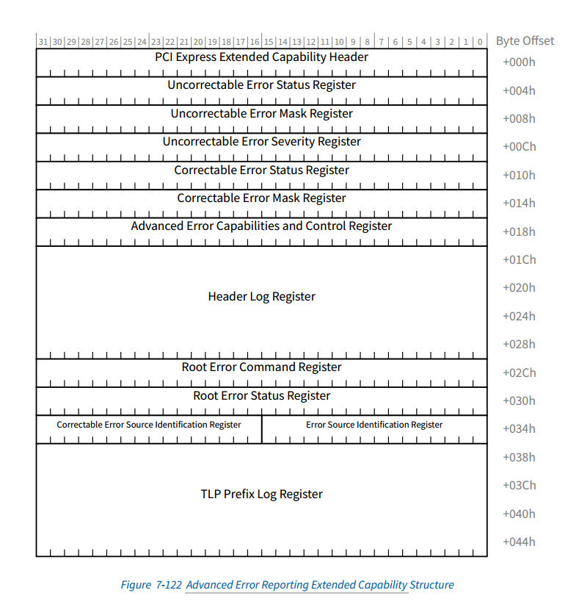

**7.8.4.7 Advanced Error Capabilities and Control Register(Offset 18h)**

**7.8.4.7 高级错误能力和控制寄存器（偏移量 18h）**

Figure 7-129 details allocation of register fields in the Advanced Error Capabilities and Control register; Table 7-105 provides the respective bit definitions. Handling of multiple errors is discussed in Section 6.2.4.2 .

图 7-129 详细说明了高级错误功能和控制寄存器中寄存器字​​段的分配；表 7-105 提供了相应的位定义。第 6.2.4.2 节讨论了多个错误的处理。

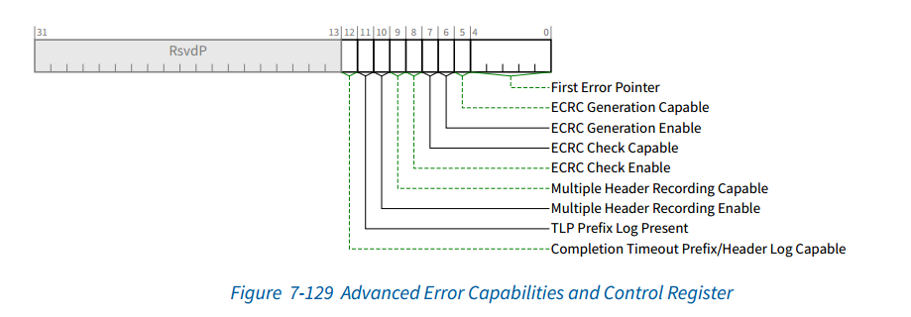

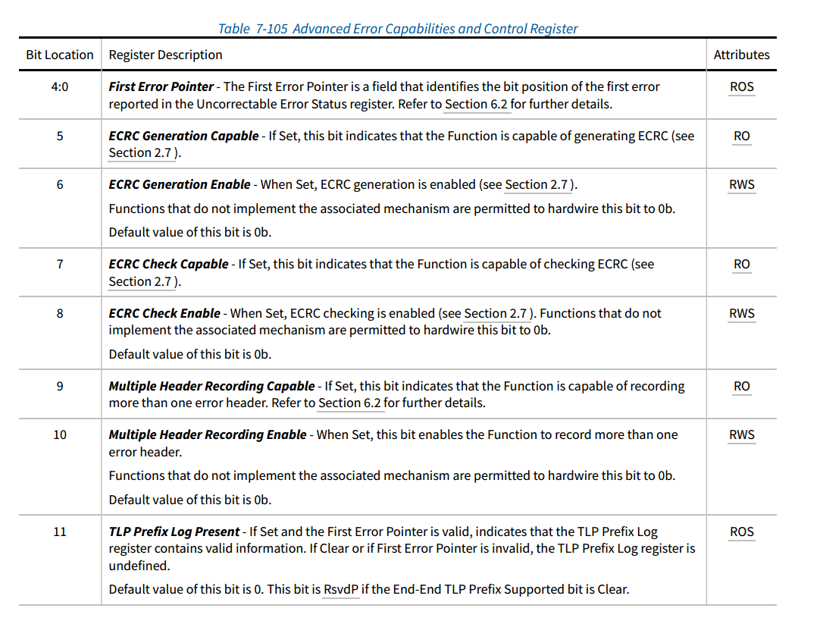对其中bit[4:0]的描述：

First Error Pointer - The First Error Pointer is a field that identifies the bit position of the first error reported in the Uncorrectable Error Status register. Refer to Section 6.2 for further details.

第一个错误指针 - 第一个错误指针是一个字段，用于标识不可纠正错误状态寄存器中报告的第一个错误的位位置。有关更多详细信息，请参阅第 6.2 节。

对其中bit11的描述：

TLP Prefix Log Present - If Set and the First Error Pointer is valid, indicates that the TLP Prefix Log register contains valid information. If Clear or if First Error Pointer is invalid, the TLP Prefix Log register is undefined.

Default value of this bit is 0. This bit is RsvdP if the End-End TLP Prefix Supported bit is Clear.

TLP 前缀日志存在 - 如果已设置且第一个错误指针有效，则表示 TLP 前缀日志寄存器包含有效信息。如果已清除或第一个错误指针无效，则 TLP 前缀日志寄存器未定义。

此位的默认值为 0。如果端到端 TLP 前缀支持位已清除，则此位为 RsvdP。

**7.8.4.12 TLP Prefix Log Register(Offset 38h)**

**7.8.4.12 TLP 前缀日志寄存器（偏移量 38h）**

The TLP Prefix Log Register captures the End-End TLP Prefix(s) for the TLP corresponding to the detected error; refer to Section 6.2 for further details. The TLP Prefix Log Register is only meaningful when the TLP Prefix Log Present bit is Set (see Section 7.8.4.7 ).

The TLP Prefixes are captured such that, when read using DW accesses, the fields of the TLP Prefix are laid out in the same way the fields of the TLP Prefix are described. Therefore, byte 0 of a TLP Prefix is located in byte 3 of the associated TLP Prefix Log Register; byte 1 of a TLP Prefix is located in byte 2; and so forth.

The First TLP Prefix Log Register contains the first End-End TLP Prefix from the TLP (see Section 6.2.4.4 ). The Second TLP Prefix Log Register contains the second End-End TLP Prefix and so forth. If the TLP contains fewer than four End-End TLP Prefixes, the remaining TLP Prefix Log Registers contain zero. A TLP that contains more End-End TLP Prefixes than are indicated by the Function’s Max End-End TLP Prefixes field must be handled as an error (see Section 2.2.10.2 for specifics). To allow software to detect this condition, the supported number of End-End TLP Prefixes are logged in this register, the first overflow End-End TLP Prefix is logged in the first DW of the Header Log register and the remaining DWs of the Header Log register are undefined (see Section 6.2.4.4 ).

The TLP Prefix Log Registers beyond the number supported by the Function are hardwired to zero. For example, if a Functions, Max End-End TLP Prefixes field contains 10b (indicating 2 DW of buffering) then the third and fourth TLP Prefix Log Registers are hardwired to zero. If the End-End TLP Prefix Supported bit (Section 7.5.3.15 ) is Clear, the TLP Prefix Log Register is not required to be implemented.

TLP 前缀日志寄存器捕获与检测到的错误相对应的 TLP 的端到端 TLP 前缀；有关更多详细信息，请参阅第 6.2 节。仅当设置了 TLP 前缀日志存在位时，TLP 前缀日志寄存器才有意义（请参阅第 7.8.4.7 节）。

捕获 TLP 前缀的方式是，当使用 DW 访问读取时，TLP 前缀的字段的布局方式与 TLP 前缀字段的描述方式相同。因此，TLP 前缀的字节 0 位于相关 TLP 前缀日志寄存器的字节 3 中；TLP 前缀的字节 1 位于字节 2 中；依此类推。

第一个 TLP 前缀日志寄存器包含来自 TLP 的第一个端到端 TLP 前缀（请参阅第 6.2.4.4 节）。第二个 TLP 前缀日志寄存器包含第二个端到端 TLP 前缀，依此类推。如果 TLP 包含的端到端 TLP 前缀少于四个，则其余 TLP 前缀日志寄存器包含零。如果 TLP 包含的端到端 TLP 前缀多于功能的最大端到端 TLP 前缀字段所指示的数量，则必须将其作为错误处理（有关详细信息，请参阅第 2.2.10.2 节）。为了允许软件检测到这种情况，支持的端到端 TLP 前缀数量将记录在此寄存器中，第一个溢出的端到端 TLP 前缀将记录在 Header 日志寄存器的第一个 DW 中，而 Header 日志寄存器的其余 DW 未定义（请参阅第 6.2.4.4 节）。

超出功能支持数量的 TLP 前缀日志寄存器将硬连线为零。例如，如果功能的最大端到端 TLP 前缀字段包含 10b（表示 2 DW 的缓冲），则第三和第四个 TLP 前缀日志寄存器将硬连线为零。如果 End-End TLP Prefix Supported 位（第 7.5.3.15 节）为 Clear，则无需实现 TLP Prefix Log Register。

